Gender and Sexuality in Ancient Greece
Pomona College — Spring 2021

Workshop One :
What and how do we know about gender and sexuality in Ancient Greece?

General Instructions: (5 minutes to introduce yourselves and read instructions)
For this workshop, you’ll be organized in a Zoom Breakout Room with a group of approximately four students. Once you have landed in your Breakout Room, please take a few minutes to introduce yourselves. Select one person to be the timekeeper. This person should keep the group moving along according to the time allotments on the worksheet. This job is crucial, since without it, the group will not complete the experience which the worksheet is designed to bring about. Select another person to the be group scribe. This volunteer will not only take notes for themself, but also be prepared to report out the group’s work.

This workshop has four parts and is designed for 2 hours and 10 minutes. There is a 15-minute break and a 15-minute moveable part, which will allow time for the faculty to pop in for a chat. Please note your start time ______ and end time _______ before beginning.

Although we must use the internet in order to meet, please refrain from using a search engine (e.g. Google) to look up answers to questions. If a question arises during discussion that you cannot answer without external research, please bring your question back to the seminar for discussion and/or use it as a writing prompt and do your research outside of class. You will need paper and something to write with for at least one part of this workshop; I recommend making notes — either on a copy of this workshop or on your own paper — throughout. Of course you may also take notes on your computer.

Moveable Part (15 Minutes)
At some point during the workshop time, Jody will pop in for a 15-minute chat.

Part One: Defining our terms (15 minutes: 5 minutes per question)
The title of our course, “Gender and Sexuality in Ancient Greece,” invites reflection. Please discuss these questions about the foundations of the course with your group. Notetaker: be prepared to share your group’s (however provisional) conclusions in class.

1. What do the terms “gender” and “sexuality” refer to? How have you developed your current understanding of these concepts? What influences and/or experiences have shaped how you think about these terms?

2. What is “ancient Greece”? What do you know about it? What images, connotations, or associations do you have with the idea of ancient Greece? Where did your ideas came from?

3. In addition to gender and sexuality, we will also be centering themes of race, ethnicity, social status, and class. Why do you think it is important for us to also consider these vectors of subjectivity in connection with gender and sexuality?

Part Two. Introducing the Greek alphabet (15 minutes)
1. (5 minutes) One of the unifying practices that defines “ancient Greece” is use of the ancient Greek language. Please take a moment to familiarize yourselves (or reacquaint yourselves if you study Greek) with the ancient Greek alphabet. Use the chart (at the end of the workshop) below to complete the following exercise.

2. (10 minutes) Working together, please (1) attempt to sound out, (2) transcribe into the Latin (English) alphabet, and (3) note/discuss the meanings of the following words.

- λόγος ___________________ — a word (spoken or written), or that by which the inward thought is expressed, and the inward thought itself.

- μῦθος _________________ — anything delivered by word of mouth, word, speech, story.

- ἄνθρωπος __________________ — human; man or woman as opposed to a god.

- θέα ___________________ — goddess.

- ψύχη _______________________ — breath; life breath; spirit.

Break (15 minutes) Please take a break and then reconvene with your small group to complete the last part of the workshop.

Part Three. Know Yourself (and Your Course). (25 minutes)
Please read over the course website, including the HOME page, the BLOG, and the COURSE INFORMATION. The best way to do this might be together, with one person sharing their screen.
- (10 minutes) As you read through the site, discuss and rephrase the course description, aims, tools, and logistics of the course. What is interesting or exciting to you about the subject matter and format of this course? What questions do you have going in? Do you have any questions or concerns about the course aims? Try to rephrase the course information and aims into one or two sentences. Write down your results.
- (10 minutes) Now, please focus on the logistics, course Pressbook: Gender and Sexuality in Ancient Greece, and SCHEDULE ONE (on the DETAILED SCHEDULE OF ASSIGNMENTS page). Note the percentage breakdown and requirements to receive full credit in this course. Do you feel that you fully understand all of the requirements? Do you have any concerns or questions?
- (5 minutes). You will be invited to report your conclusions and ask questions when we reconvene. Please work, as a group, to develop some response to the course information and Pressbook — perhaps trying to offer both a positive (e.g. we are excited about….) and a negative (e.g., we are worried or confused about…..) comment or question.

Part Four: Reflecting on Your Positionality and Developing Your Aims (40 minutes)
- (15 minutes) The people and culture of Ancient Greece are not the only focus of this course; we each bring our own subjectivity and positionality to our scholarly work, and self-reflection will be an important part of what we do. For this part of the workshop, please take five minutes to journal to yourself and then reconvene with your small group and discuss how your positionality as individuals has informed the perspective you bring to our inquiry. Consider: How have race, class, gender, sexuality, social status, and other subjectivities (taken together, your positionality) shaped the interests that brought you to this course? What advantages helped you arrive here? What obstacles have you overcome to be here today?
- (5 minutes) Your Student Contract asks you to identify your aims for this course. In order to develop your answer to this question, please take a moment to reflect now. What are your aims for this class? Why will being self-reflective be important in helping you work toward those aims?
- (10 minutes) Please share out and discuss your thoughts to question one above with your group. Are your aims similar or different? Does hearing about your colleagues’ aims help you revise or develop your own?
- (5 minutes) For the last five minutes of the workshop, please fill out and submit the STUDENT SURVEY AND CONTRACT.

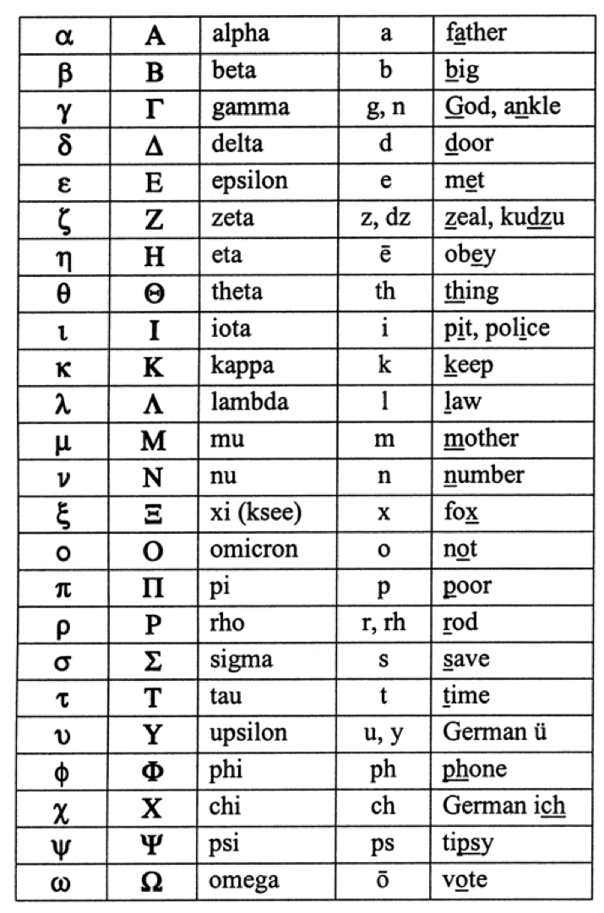
*note that ς also appears for sigma at the end of a word.

